RAYA

Runtime Proof ? 28_26
Phase 4 farmer persistence and advisory differentiation
Phase 5 Field Timeline work completed today
Runtime validation date: 27 September 2026 | App: http://127.0.0.1:8505 | Evidence source: live Streamlit UI and persistent runtime records

Executive result
Phase 4 runtime gate: PASS. Both saved farmers survived a full Streamlit process restart. Using the same Rice / Flowering / Karnataka / Mandya input, the two stored farmer-specific advisories differed in recommendation count, priorities, and context-specific guidance, and were stored under separate farmer/field history records. Instrumented live execution recorded one farmer_search() call for each generation request.
Phase 5 work completed today: PASS. Persistent field events, timeline reasoning, automatic event recording, and the read-only Field Timeline page were validated with a live seven-event field history and six passing focused tests.
Gate | Result | Evidence
Phase 4 runtime proof | PASS | Restart, re-load, matching input, differentiated outputs, separate history, one farmer_search() call per request
Phase 5 acceptance checks | PASS | Live timeline persisted after restart; 30/60-day logic and deterministic rules validated; 6 focused tests passed

Phase 4 ? end-to-end runtime steps

1. Create and save Farmer A
Created and saved Runtime Proof Farmer A - 20260927 from Farmer Setup. Profile: Mandya, Karnataka; 24 years? experience; limited labor; low budget; preventive guidance; organic inputs.

2. Create and save Farmer B
Created and saved Runtime Proof Farmer B - 20260927 with different context. Profile: Mandya, Karnataka; 2 years? experience; sufficient labor; high budget; reactive guidance; chemical inputs.

3. Restart the application
Stopped the prior Streamlit listener (PID 21388), started a new listener (PID 32576), and confirmed the local app returned HTTP 200. Browser page was reloaded after restart.

4. Confirm persistence
Both named demo farmers appeared in the post-restart Farmer Registry selector and were loaded individually. Both farmer records retain the same Mandya, Karnataka location.

5. Match advisory inputs
Each farmer?s saved advisory packet has crop rice, stage Flowering, state Karnataka, district Mandya. Each is linked to its own saved farm and field.

6. Generate and compare
The saved comparison advisories are ADV_D1ADB895057B for Farmer A and ADV_6303E82D3D7B for Farmer B. Both have overall priority Critical; recommendation composition and priority differ with farmer context.

7. Confirm separate history
Farmer A?s field history contains its own advisory record(s); Farmer B?s field history contains a separate record. The Farmer B history screen shows one saved advisory; Farmer A?s proof field history shows three, including the later Phase 5 timeline demonstrations.

8. Count farmer search
Live entry/exit instrumentation observed exactly one farmer_search() invocation during each of the two Phase 4 advisory generation requests. The app?s generate screen also states the one-call path.

Farmer A vs Farmer B ? persisted comparison
Attribute | Farmer A | Farmer B
Persistent farmer | Runtime Proof Farmer A - 20260927 | Runtime Proof Farmer B - 20260927
Location | Mandya, Karnataka | Mandya, Karnataka
Farming experience | 24 years | 2 years
Labor availability | Limited | Sufficient
Budget constraint | Low | High
Guidance preference | Preventive | Reactive
Preferred input type | Organic | Chemical
Field | FIELD_206CC6EA74D0 | FIELD_3B41D3B86F7F
Input: crop / stage / state / district | Rice / Flowering / Karnataka / Mandya | Rice / Flowering / Karnataka / Mandya
Phase 4 comparison advisory | ADV_D1ADB895057B | ADV_6303E82D3D7B
Overall priority | Critical | Critical
Recommendations | 20 | 17

The overall priority remains Critical for both because the shared crop-stage/weather risk is Critical. The evidence of personalization is in recommendation selection and priority: Farmer A receives budget/labor/preventive guidance and low-budget/limited-labor reasons; Farmer B receives no farmer-context reasons in this advisory and has several critical-operation recommendations at Medium rather than Farmer A?s Low. The persisted packet also confirms the same crop, stage and location for both requests.
Observable output difference | Farmer A | Farmer B
Context actions | Budget, labor, and preventive guidance recommendations are present. | Those farmer-context actions are absent from this record.
Critical-operation prioritization | Five critical-operation actions are Low; personalization cites limited labor. | The corresponding five operations are Medium; no labor personalization reason.
Recommendation count | 20 | 17
Decision explanation | Limited labor and low-budget rationale is attached to personalized actions. | No farmer-context personalization reasons on this advisory.

Advisory History evidence
The screenshots below are live UI captures after restart. The expanded Farmer A timeline-aware record (ADV_99345455E8A9) is an additional Phase 5 demonstration; it is distinct from the Phase 4 A/B comparison advisory (ADV_D1ADB895057B).

Screenshot 1 ? Farmer A saved and reloaded
Farmer A is selected from the existing-farmer registry after restart. Persistent identity and location are also reflected in the comparison table above.
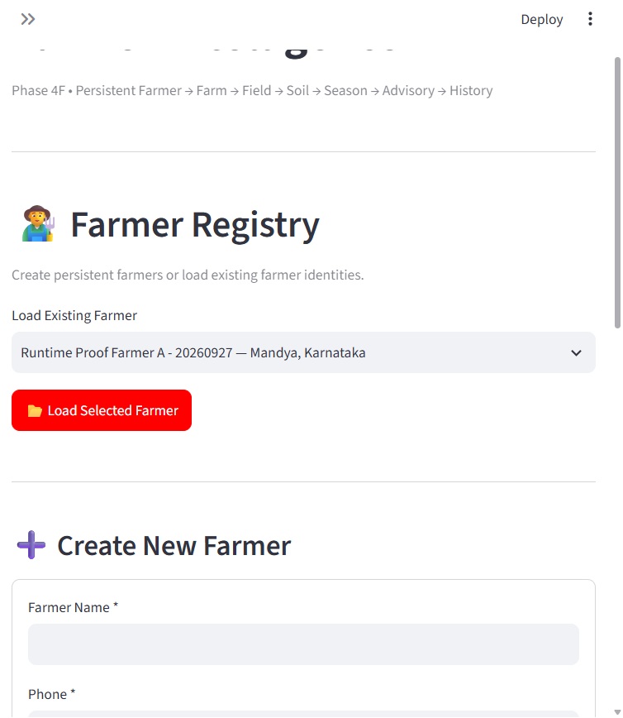

Screenshot 2 ? Farmer B saved and reloaded
Farmer B is selected from the existing-farmer registry after restart, with the same Mandya, Karnataka location and a distinct saved profile.
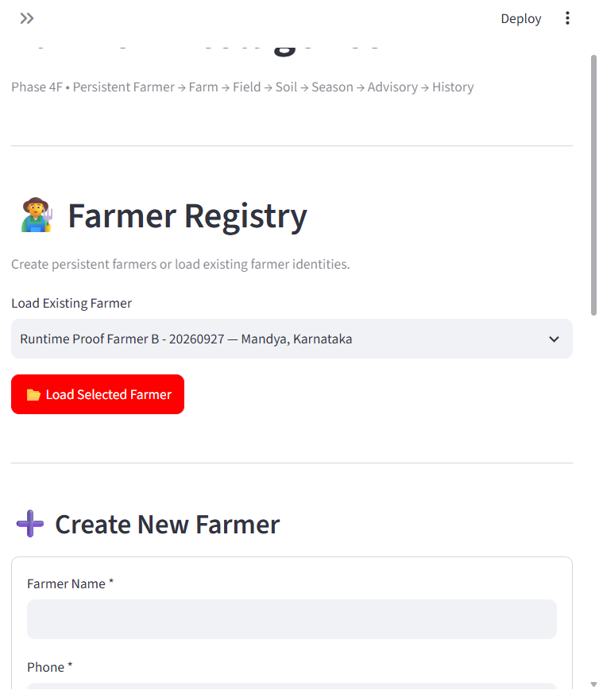

Screenshot 3 ? Both farmers survived restart
The post-restart existing-farmer selector includes both Runtime Proof Farmer A and Runtime Proof Farmer B.
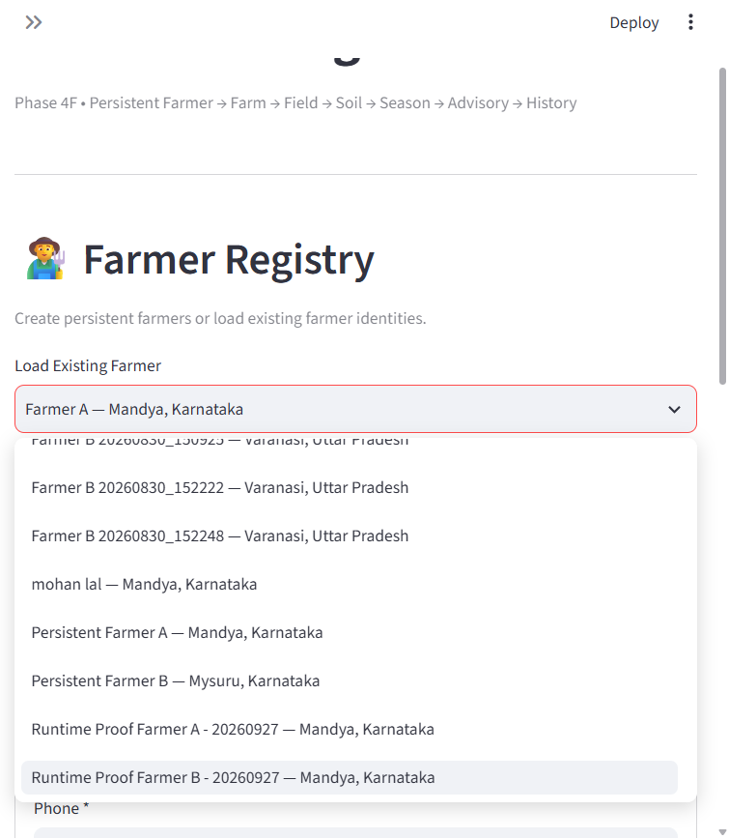

Screenshot 4 ? Farmer A advisory context
Live Generate Advisory screen: Runtime Proof Farmer A, Runtime Proof Farm/Field, Rice; backend path displays farmer_search() once only.
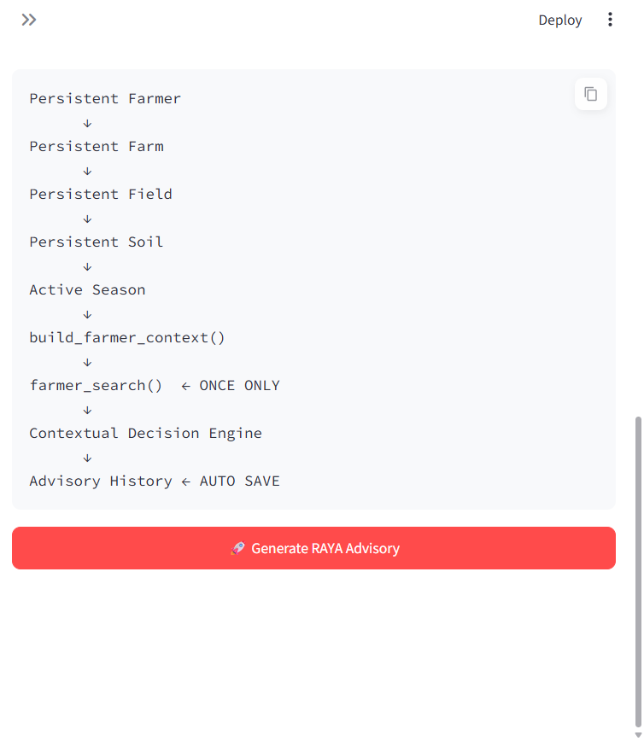

Screenshot 5 ? Farmer B advisory context
Live Generate Advisory screen: Runtime Proof Farmer B, its own Runtime Proof Farm/Field, Rice; same location and Flowering stage are confirmed by the saved packets.
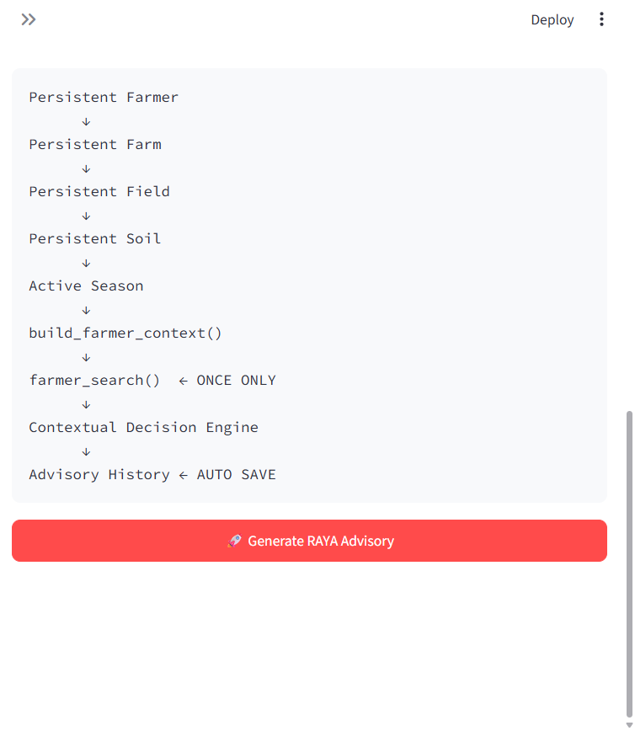

Screenshot 6 ? Farmer A Advisory History
Farmer A?s field shows separate persisted advisory history entries, including the Phase 4 and Phase 5 records.
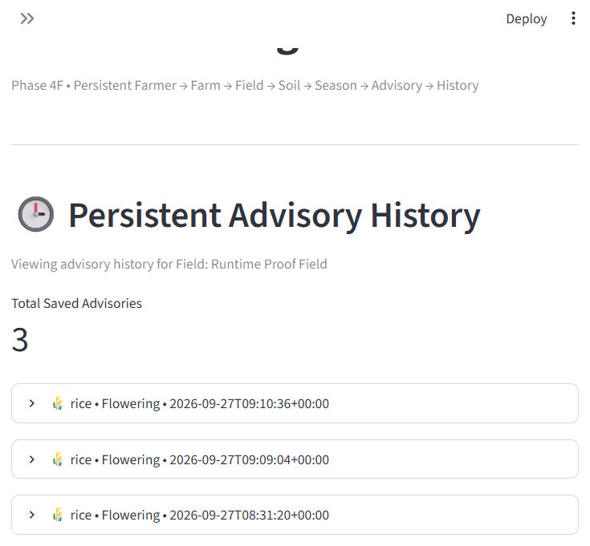

Screenshot 7 ? Farmer A expanded advisory
Expanded, persisted Farmer A timeline-aware advisory ADV_99345455E8A9 shows the recommendation set and history-based personalization reasons.
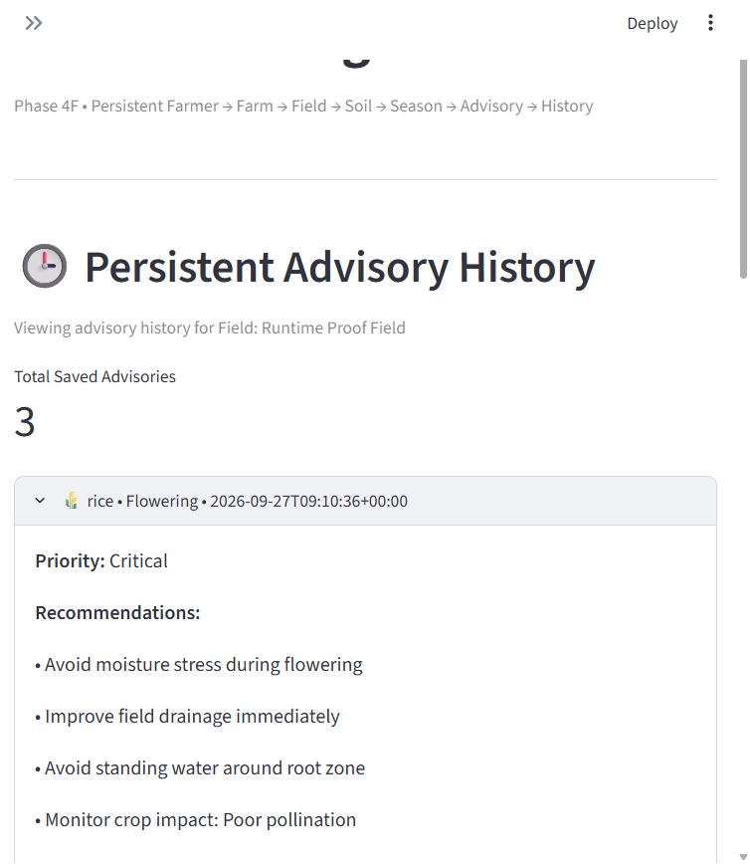

Screenshot 8 ? Farmer B Advisory History
Farmer B?s history is scoped to the Farmer B field and contains its own saved Rice/Flowering advisory.
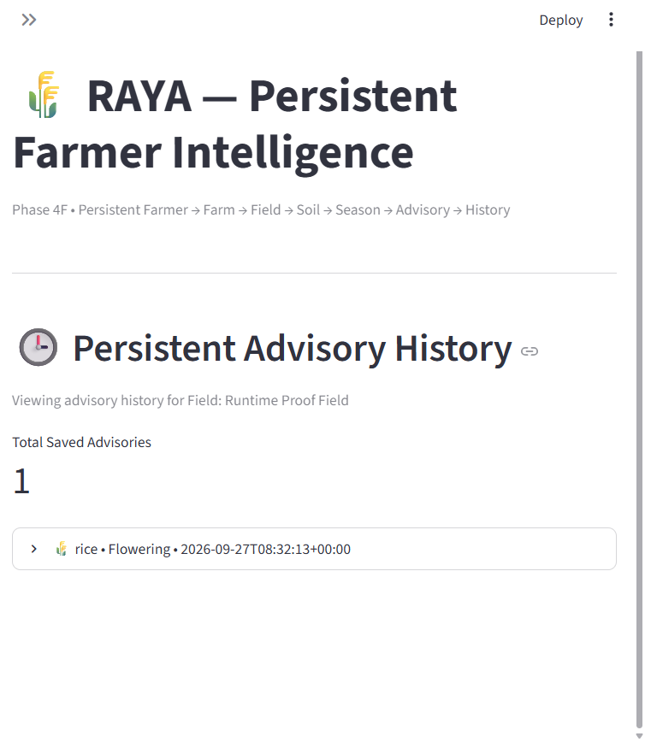

Screenshot 9 ? Farmer B expanded advisory
Expanded Farmer B advisory history record shows its stored Critical priority and its recommendation list.
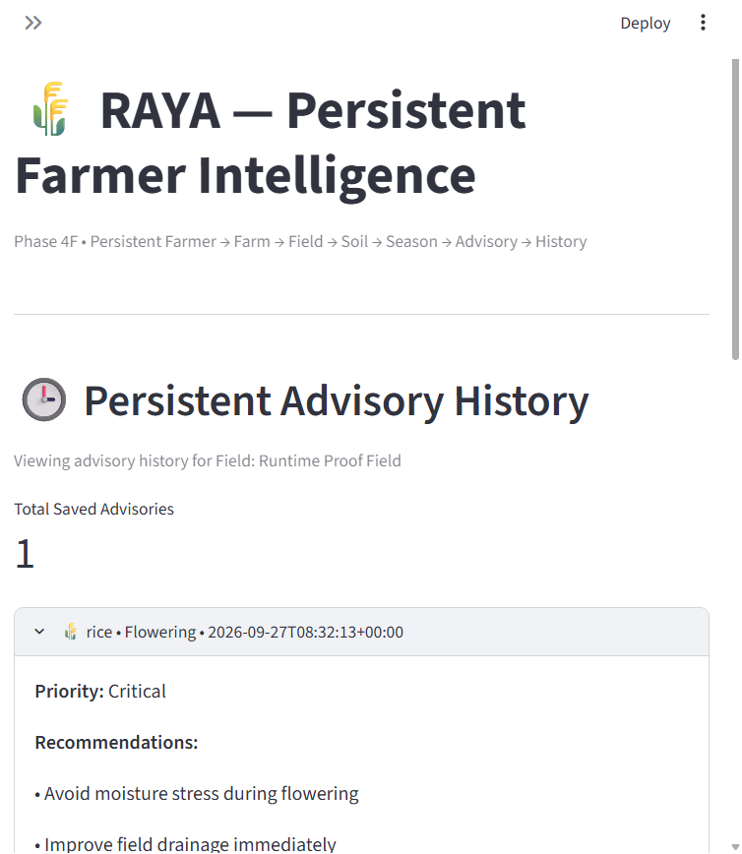

Today?s additional work ? Phase 5 Field Timeline
Phase 5 adds persistent field history and deterministic time-aware reasoning without changing Crop Master, Weather, Water, Disease, or Market intelligence. RAYA now uses field events to interpret what happened over time.
Today?s work | Delivered / verified
Persistent event store | Field-scoped activity records with validation and unique idempotency keys; atomic unique insertion through persistent storage.
Timeline Manager | Chronological field history plus last-30-day and last-60-day retrieval.
Automatic recording | New season creation records a sowing event; a successful advisory records one advisory_generated event.
Deterministic timeline reasoning | Heavy rain within 7 days after fertilizer; repeated irrigation within 7 days; blast observation in the active season.
Streamlit page | Read-only Field Timeline page lists backend records chronologically for the selected field.
Live field demonstration | FIELD_206CC6EA74D0 has seven records: blast, nitrogen fertilizer, heavy rainfall, two irrigations, and two separately keyed advisory events.
History-aware advisory | ADV_99345455E8A9 adds nutrient-loss inspection (High), blast scouting (High), and moisture-pattern review (Medium), with timeline evidence in reasons.

Phase 5 deterministic signals observed
History evidence | Reasoning output
Nitrogen applied 19 Sep; 74 mm heavy rain 23 Sep (4 days later) | Inspect for nutrient loss before the next fertilizer application (High).
Two canal irrigation events on 24 and 25 Sep | Review the recent soil moisture pattern before the next irrigation (Medium).
Rice blast observation on 17 Sep in the active season | Increase blast scouting based on the previous field observation (High).

Screenshot 10 ? Persistent Field Timeline after restart
Live Field Timeline page for Runtime Proof Farmer A / Runtime Proof Field. It displays the chronological persisted events and both advisory IDs.
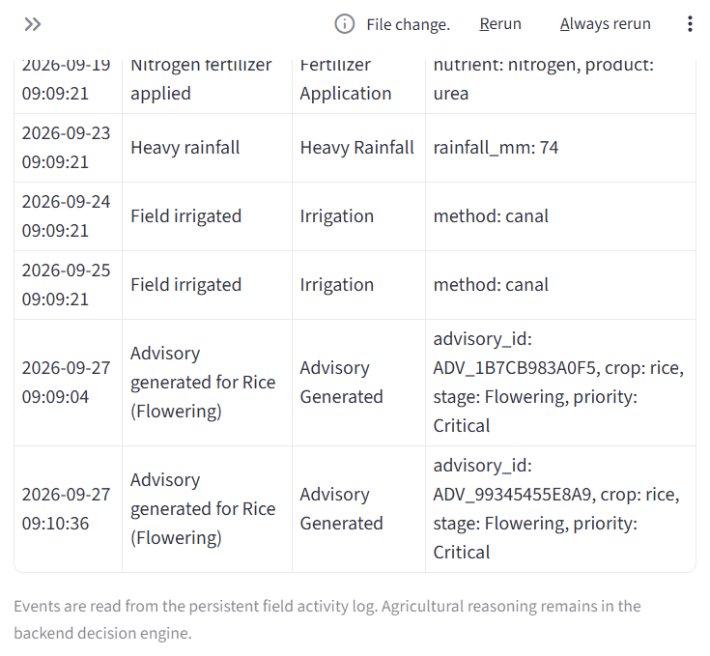

Final PASS / FAIL summary
PASS Farmer A created/saved and reloaded after app restart.
PASS Farmer B created/saved with different profile context and reloaded after app restart.
PASS Same crop, stage, state, and district confirmed in both saved advisory packets: rice, Flowering, Karnataka, Mandya.
PASS Outputs differ by recommendation count and farmer-context actions/priorities (20 vs 17); overall priority Critical for both.
PASS Advisories are separately stored under distinct farmer IDs, field IDs, advisory IDs, and history views.
PASS Exactly one farmer_search() invocation was observed for each Phase 4 advisory request in live instrumentation.
PASS Phase 5 live timeline persists through restart and returns chronological field-scoped events.
PASS Phase 5 isolated validation passed; all six focused Phase 5 unit tests passed.
PHASE 4 RUNTIME GATE: PASS ? runtime proof is complete and the Phase 4 lock can proceed from the evidence recorded here.
Phase 5 verification: PASS. Focused test run: 6/6 passed. The isolated runtime validation returned PASS with 5 deduplicated records, correct 30-/60-day counts, and all three expected deterministic temporal rules.

Implementation and verification references
- persistent_memory/field_activity_log.py ? field event schema and persistence.
- persistent_memory/timeline_manager.py ? history windows and deterministic reasoning.
- persistent_memory/storage_manager.py ? persistent entity and atomic idempotent insert.
- persistent_memory/season_manager.py ? automatic sowing event.
- persistent_memory/persistent_pipeline.py ? timeline handoff and advisory event recording.
- contextual_decision_engine.py ? backend-owned personalization and timeline reasons.
- raya_farmer_interface.py ? Farmer Setup, Advisory History, and Field Timeline UI.
- persistent_memory/phase5_validation.py ? isolated end-to-end validator.
- tests/test_phase5_timeline.py ? six focused tests.
- docs/phase5_handover.md ? Phase 5 handover.
Verification command | Result
python -m unittest tests.test_phase5_timeline -v | PASS ? 6 tests
python -m persistent_memory.phase5_validation | PASS ? 30/60-day retrieval, deduplication, three temporal rules
Live app restart + local HTTP check | PASS ? new Streamlit listener; HTTP 200; post-restart UI reload

